A000-US-MA-Swampscott-Pointed Blades-Spades and Canoe Anchor-Hafted-Lithic-7,000 BP

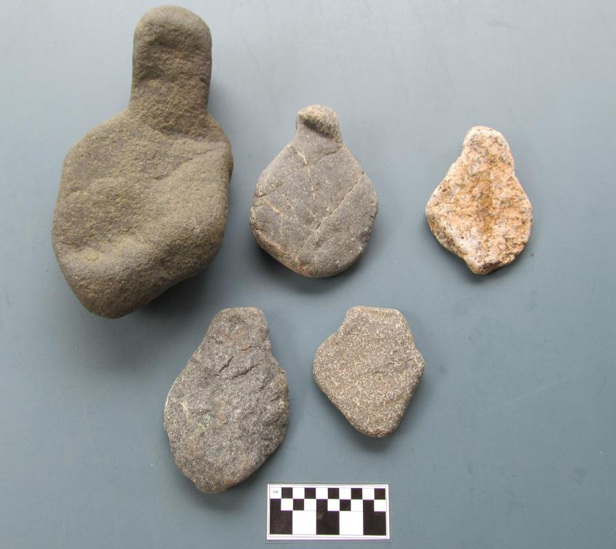

Figs. 1-5. US-MA-Swampscott-Spades-Hafted, Pointed Blade-Lithic-7,000 BP

**Case no.: 11**

**Accession Numbers: A**

**Formal Label:** US-MA-Swampscott-Spades-Hafted, Pointed Blade-Lithic-7,000 BP

**Display Description:**

These large spades were used for clamming in the littoral level off Swampscott, MA, while the heavier Canoe Anchor was used for anchoring a Canoe while fishing.

**LC Classification: E 78**

**Date or Time Horizon:** 7,000 BP

**Geographical Area:** **late archaic, marine oriented people on the central New England coast**

**Map:**

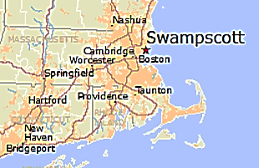 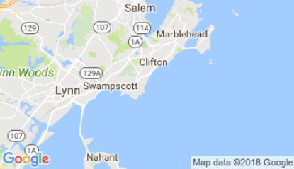

**GPS coordinates:**

**Cultural Affiliation:** late archaic, marine oriented people on the central New England coast

**Media:** No 1. Basalt; Nos.. 2, 4, 5, andesite; No. 3 granite.

**Dimensions:**

**Weight:**

**Condition: original**

**Provenance:** Swampscott, MA

**Discussion:**

**References:**

Robinson, Brian S. 1985. ***The Nelson Island and Seabrook marsh sites : late archaic, marine oriented people on the central New England coast / by Brian S. Robinson. Ceramic analysis in the northeast: contributions to methodology and culture history* / edited by James B. Petersen.** Rindge, N.H.: Fund for Anthropology, Dept. of Anthropology, Franklin Pierce College.